Project Objectives:

Present all the MB project into map with markers, so that they can be visualized and analysed on the map.

Implementation
Use free licenced Google Map API to request map from Google server and display all the project, which are stored in the database, and display markers according to their co-ordinates

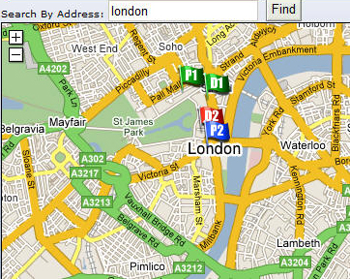
Functionalities:
- Search:
The system can send the address in the textbox to Google Geocode Server and display the appropriate map back to local server.
- Use different icons to indicate different project status and department the project belong to

Status  Department | Planning | Bidding | Implementation | Finish
Planning 1 |  |  |  | 
Planning 2 |  |  |  | 
Planning 3 |  |  |  | 
Designing 1 |  |  |  | 
Designing 2 |  |  |  | 
Designing 3 |  |  |  | 
Modelling |  |  |  | 

